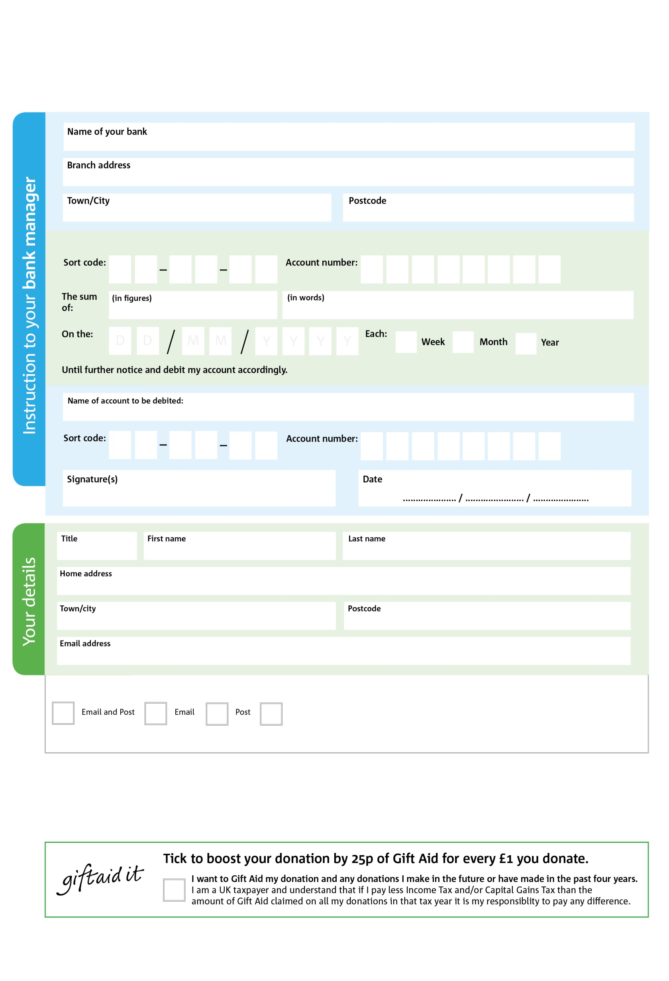

2

Reg. Charity No: 1136965 Reg. in England & Wales

**Please pass this form onto the foodbank, using the foodbank’s address at the bottom, who will save a copy for their records.   
They will then send it onto your named bank or building society.**

Please pay Oasis Hub Waterloo: (Waterloo Foodbank is part of Oasis Hub Waterloo your contribution will be restricted to Waterloo Foodbank)

**Data protection**

*'Waterloo Foodbank – part of Oasis Hub Waterloo is committed to protecting your privacy and will process your personal data in accordance with current Data Protection legislation. Waterloo Foodbank collects information to keep in touch with you and supply you with information relating to our work. To unsubscribe from our newsletter, send a message to the email address above with the word unsubscribe in the subject line. A full data privacy statement for financial donors is available from the foodbank on request.’*

POSTAL ADDRESS: Waterloo Foodbank, Oasis Centre, 1 Kennington Road, London, SE1 7QP

3

V

5

V

8

V

7

V

8

V

1

V

3

V

9

V

2

8

5

6

0

We would love to keep you up to date with information about Waterloo Foodbank. Please tick your preference:

You can change your preferences any time by contacting us on 02079214205 or emailing us at foodbank@oasiswaterloo.org

I do not wish to receive future communications from Waterloo Foodbank

**Standing Order Mandate**

**waterloo.foodbank.org.uk**

You can change your preferences any time by contacting us on XXXXXXXXXXX or emailing us at XXXX@XXXXXXXXXX.foodbank.org.uk

I do not wish to receive future communications from XXXXXX Foodbank